**Name: Nafinur Leo**

**Id: 20-42195-1**

**Course Name: Data Communication**

**Section: D**

**Lab Assignment: Final term**

**Semester: 2021-2022 Fall**

**Submission Date: 10-12-2021**

ID = AB-CDEFG-H

Here, my id is: 20-42195-1

A = 2, B = 0, C = 4, D = 2, E = 1, F = 9, G = 5, H = 1

String: 9Nl5

**Code:**

clc;

clear all;

close all;

Transmitted_Message = '9Nl5';

dec = double(Transmitted_Message);

p2 = 2.^(0:-1:-7);

B = mod(floor(p2'*dec),2);

x = reshape(B,1,numel(B));

disp('Transmitted message is:')

disp(Transmitted_Message)

disp('Binary information at transmitter:');

disp(x);

G=5;

br=(G+2)*10;

bp = 1/br;

bit = [];

a0 = 0;

a1 = (G+5);

a2= 2*(G+5);

a3= 3*(G+5);

nt = 1000;

for n =1:2:length(x)

if x(n) == 0 && x(n+1)== 0 ;

se = a0*ones(1,nt);

elseif x(n) == 0 && x(n+1)== 1;

se = a1*ones(1,nt);

elseif x(n) == 1 && x(n+1)== 0;

se = a2*ones(1,nt);

elseif x(n) == 1 && x(n+1)== 1;

se = a3*ones(1,nt);

end

bit = [bit se];

end

t = 0:2*(bp/nt):(length(x)*bp-bp/nt);

figure

plot(t,bit,'lineWidth',2.5);

ylabel('Amplitude(volt)');

xlabel('Time(sec)');

title('Unipolar digital signal');

f =(G+2)*100;

t1 =0:bp/nt:bp-bp/nt;

ss = length(t1);

m = [];

for (i = 1:2:length(x))

if (x(i) == 0 && x(i+1)== 0 )

y = a0*cos(2*pi*f*t1);

elseif (x(i) == 0 && x(i+1)== 1 )

y = a1*cos(2*pi*f*t1);

elseif (x(i) == 1 && x(i+1)== 0 )

y = a2*cos(2*pi*f*t1);

else (x(i) == 1 && x(i+1)== 1 )

y = a3*cos(2*pi*f*t1);

end

m = [m y];

end

t = 0:2*(bp/nt):(length(x)*bp-bp/nt);

figure

plot(t,m);

xlabel('Time(sec)');

ylabel('Amplitude(volt)');

title('Modulated signal at transmitter');

disp(' Message transmitted through a Transmission medium');

t = 0:2*(bp/nt):(length(x)*bp-bp/nt);

Rec=awgn(m,10);

figure

plot(t,Rec,'linewidth',2);

xlabel('Time(sec)');

ylabel('Amplitude(volt)');

title('Received signal at receiver');

nq = length(x)/2;

mn = [];

for q = 1:nq

t_in = 0:bp/nt:bp-bp/nt;

y = cos(2*pi*f*t_in);

mm = y.*Rec(((q-1)*nt+1):q*nt);

z = trapz(t_in,mm);

zz = round((2*z/bp));

if(zz > ((a0+a1)/2) && zz < ((a1+a2)/2))

a = 0;

a5 = 1;

elseif(zz >((a1+a2)/2) && zz < ((a2+a3)/2))

a = 1;

a5 =0;

elseif(zz >((a2+a3)/2))

a = 1;

a5 =1;

else

a = 0;

a5 = 0;

end

mn = [mn a a5];

end

disp(' Binary information at reciver :');

disp(mn);

bit = [];

nt = 1000;

for n =1:2:length(mn)

if x(n) == 0 && x(n+1)== 0 ;

se = a0*ones(1,nt);

elseif x(n) == 0 && x(n+1)== 1;

se = a1*ones(1,nt);

elseif x(n) == 1 && x(n+1)== 0;

se = a2*ones(1,nt);

elseif x(n) == 1 && x(n+1)== 1;

se = a3*ones(1,nt);

end

bit = [bit se];

end

t = 0:2*(bp/nt):(length(x)*bp-bp/nt);

figure

plot(t,bit,'lineWidth',2.5);

ylabel('Amplitude(volt)');

xlabel('Time(sec)');

title('Received unipolar digital signal');

L = length(mn);

L8 = 8*floor(L/8);

B = reshape(mn(1:L8),8,L8/8);

p2 = 2.^(0:7);

dec = p2*B;

txt2 = char(dec);

disp('Received Message is:')

disp(txt2);

a)

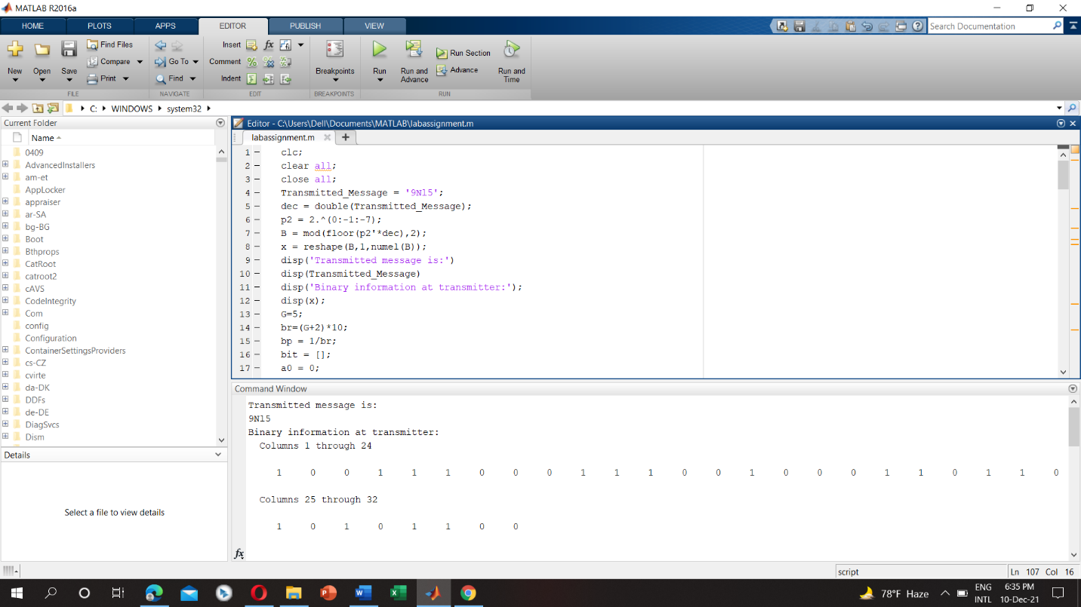

b)

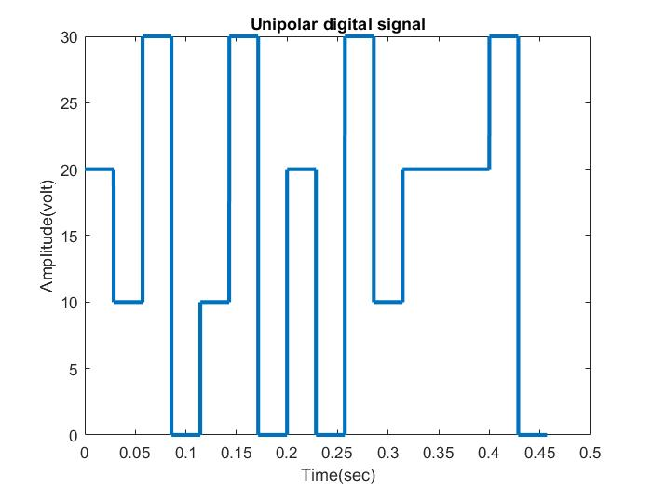

c)

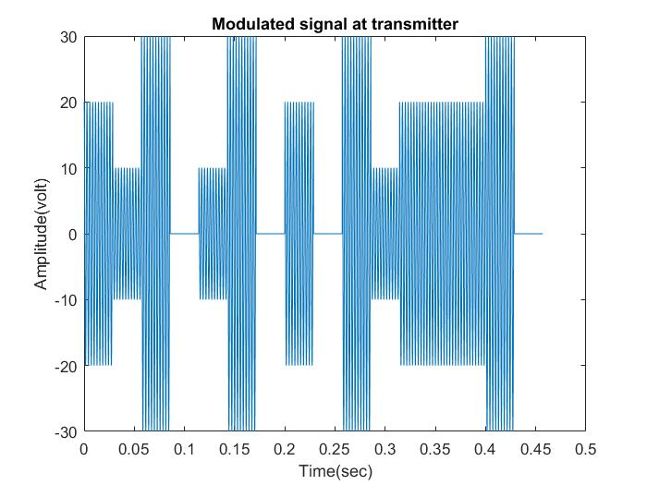

d)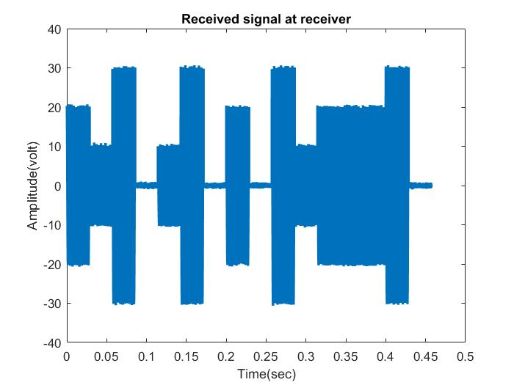

e)

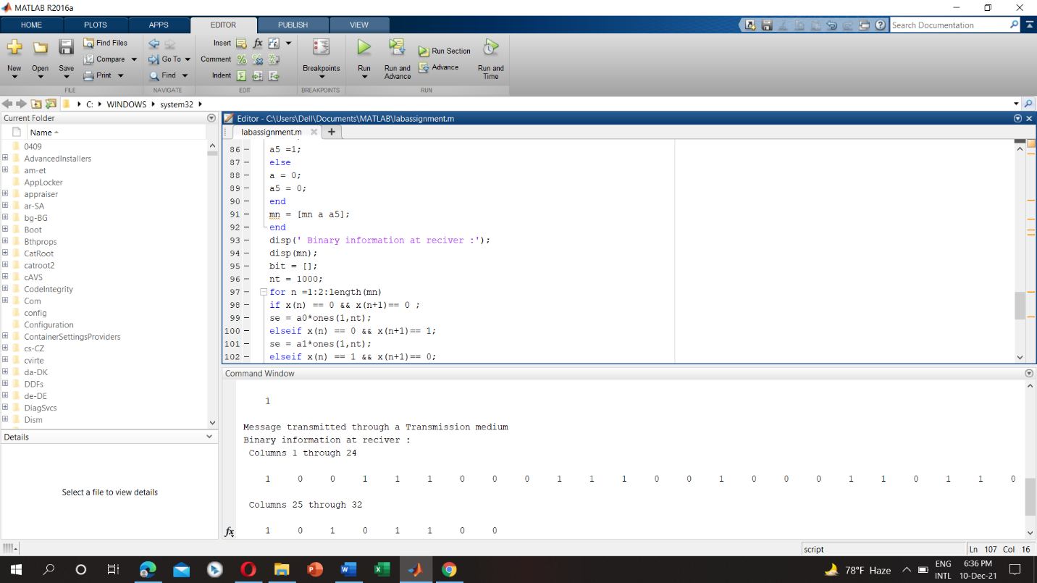

f)

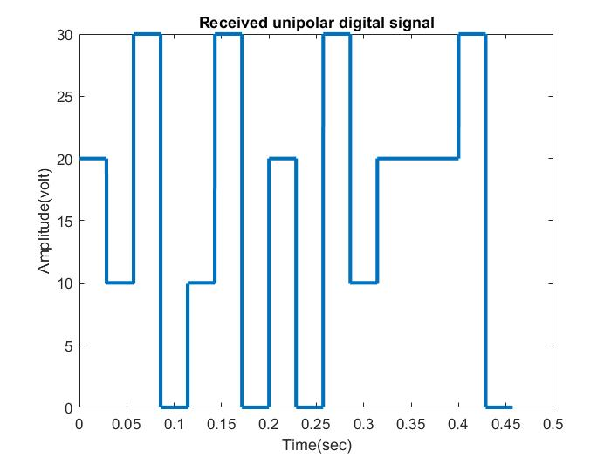

g)

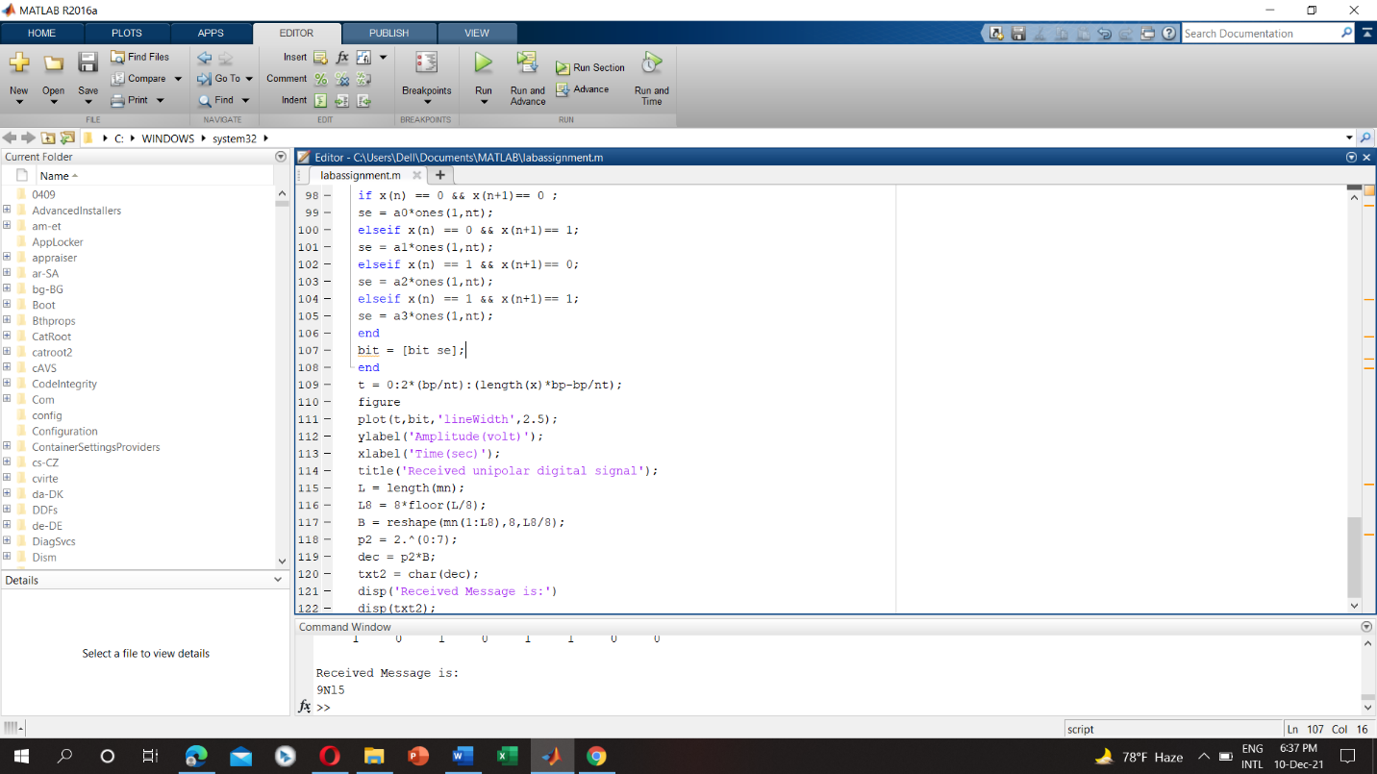

h) Noise is an unwanted signal which interferes with the original message signal and corrupts the parameters of the message signal. This alteration in the communication process, leads to the message getting altered. If we increase noise power in modulated signal, it’ll take more energy for transmission. As a result, it’ll increase cost and there will be a chance for data loss. But if we decrease noise power, it’ll take less energy for transmission as well as it reduces cost and there’ll less chance for data loss.

**Discussion:**

There is some of the bugs concluded with the definite organizational complementation with the functions of the MATLAB. The regression of the functions originated from the libraries inclines the comprehensive objective of this complementation. I face some problems while creating the plot and also face problems while calculation using my student id number. MATLAB takes some time while I try to run because my laptop configuration is low.